REPORT

On contract research for
Nsovo Environmental Consulting (Pty) Ltd

SOIL INFORMATION FOR
PROPOSED FOSKOR-MERNSKY
TRANSMISSION LINE,
LIMPOPO PROVINCE

By

D.G. Paterson (Pr. Nat. Sci. 400463/04)

June2012

Report No. GW/A/2012/xx

ARC-Institute for Soil, Climate and Water,
Private Bag X79, Pretoria 0001, South Africa

Tel (012) 310 2500 Fax (012) 323 1157
Declaration:

I declare that the author of this study is a qualified, registered natural scientist (soil science), is independent of any of the parties involved and has no other conflicting interests.


D.G. Paterson

CONTENTS Page

1 Introduction 4

2 Study Area 4

2.1 Terrain 5

2.2 Climate 5

2.3 Geology 6

3 Methodology 6

4 Soils 9

5 Agricultural Potential 9

5.1 Erodibility 11

6 Impacts and Recommendations 11

6.1 Impacts 11

6.2 Fatal Flaws 12

References 13

Appendix 1: Land Type Map

Appendix 2: Agricultual Potential Map
1 INTRODUCTION

The ARC-Institute for Soil, Climate and Water was requested by Nsovo Environmental Consulting to carry out an investigation of the soils and agricultural potential for a proposed Foskor Merensky 275Kv 130km power line in Limpopo Province.

2 STUDY AREA

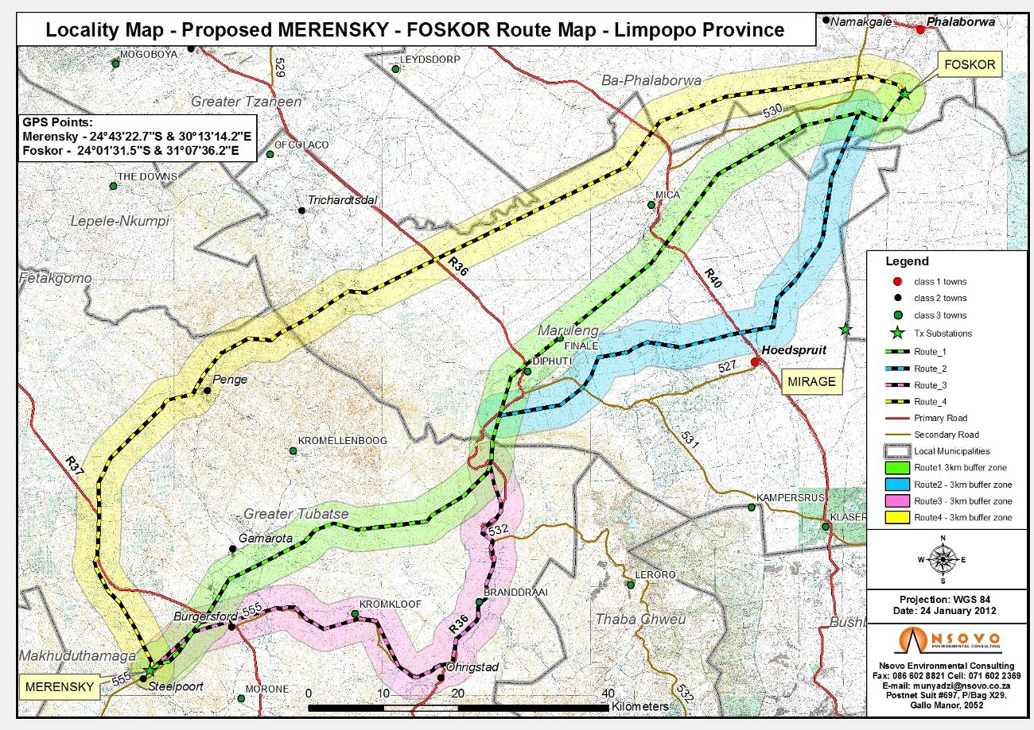
The proposed route runs from the Merensky substation, near Steelpoort, to the Foskor substation, south of Phalaborwa. The location of the route is shown in Figure 1.

Figure 1 Locality map

Four possible routes are proposed. Route 1 is the central alternative, running north-eastwards from Steelpoort past Burgersfort, Diphuti and south of Mica to the Foskor substation. Route 2 is a southern diversion to the east of the Drakensberg, running past Hoedspruit, while Route 3 is a southern diversion to the west of the Drakensberg, running close to Ohrigstad. Finally, Route 4 is the northern alternative, running past Penge, and to the north of Mica on the way to Foskor.

2.1 Terrain

The terrain within the study area varies greatly. Within the valleys to the west of the Drakensberg, the slopes are relatively flat, generally around 2-10%. However, the Drakensberg range must be crossed at some or other point and slopes here are much steeper, exceeding 100% (45º) in many places. However, on the eastern side of the mountains, the topography is generally much gentler, with slopes again less than 10% for most of the landscape. Altitude above sea level is around 800-900 m in the west, 1500-1800 m on the top of the Drakensberg and 400-500 m in the east.

The major river in the area is the Olifants River, which runs towards the east, and its tributaries, including the Blyde River and Selati River.

2.2 Climate

Climate data was obtained from the national Land Type Survey (Paterson, Koch & Barrow, 1989).

As for the terrain, the climate of the area varies significantly. Rainfall in the area of the Steelpoort valleys is low, around 500 mm per year, while on the higher mountains it rises to around 900-1200 mm per year. On the eastern side of the mountains, there is a definite rain shadow effect and figures are again low, around 400-500 mm.

Frost will occur in the west, although occasional, while the lowveld is generally frost-free, due to the drop in altitude.

2.3 Geology

The area is underlain by varying parent materials, from shale, norite and pyroxenite of the Bushveld Complex in the west, shale and quartzite of the Transvaal Sequence in the mountains and Archean granite and gneiss in the east (Geological Survey, 1984).

3 METHODOLOGY

As far as existing soil information is concerned, the area is covered by two land type maps at a scale of 1:250 000, which have been digitized using ArcGIS. The study area falls within the map sheets 2330 Tzaneen and 2430 Pilgrim’s Rest.

Each specific land type is a unique combination of broad soil pattern, terrain type and macroclimate. Where any of these changes, a new land type occurs.

Within any specific land type, the soil forms occurring (MacVicar et al, 1977) have been summarized according to their dominance, but the locality or distribution of the various soils within a land type cannot be further determined.

4. SOILS AND AGRICULTURAL POTENTIAL

As indicated on the land type map in Appendix 1, there are a number of separate land types occurring within the study area. These are summarized as follows:

Ae27, Ae115, Ae116, Ae117, Ae119, Ae120, Ae121, Ae122, Ae129, Ae130, Ae131 (Red, lightly weathered, structure less soils)
Ea88 (Dark, swelling clay soils)
Fa 348, Fa350, Fa351, Fa352, Fa353, Fa359 (Shallow soils, sometimes rocky, little lime)
Fb171, Fb172, Fb175, Fb176, Fb177, Fb178, Fb179, Bd180, Fb181, Fb182, Fb183, Fb186, Fb187 (Shallow soils, sometimes rocky, occasionally some lime)
Ib31, Ib51, Ib155, Ib157, Ib180, Ib181, Ibi84, Ib185, Ib186, Ib187, Ib188, Ib189, Ib190, Ib191, Ib192, Ib197, Ib239, (Rocky areas [>60% rock], often steep with shallow soils)
Ic154, Ic157 (Very rocky areas [>80% rock], usually steep with shallow soils)

The main characteristics of each of the land types are given in Table 1 below (the colours correspond to the map). The soils were classified according to MacVicar et al, 1977).

LAND  TYPE | DOMINANT SOIL(S) | DOMINANT  DEPTH  (mm) | DOMINANT SOIL CHARACTERISTICS | AGRIC. POTENTIAL
 |  |  |  | HIGH | MOD | LOW
Ae27 | Hutton 36/46 | 450-1200 | Red, structureless, often calcareous, loamy soils on rock | 33 | 50 | 17
Ae115 | Hutton 36/46/47 | 900-1200 | Red, structureless, often calcareous, loamy/clayey soils on rock | 82 | 16 | 2
Ae116 | Hutton 36/37 | 900-1200 | Red, structureless, loamy/clayey soils on rock | 3 | 9 | 88
Ae117 | Hutton 36/46 | 300-500 | Red, structureless, often calcareous, loamy soils on rock | 30 | 50 | 20
Ae119 | Hutton 36 | 300-450 | Red, structureless, loamy/clayey soils on rock | 24 | 20 | 56
Ae120 | Hutton 36/46 | 800-1200 | Red, structureless, often calcareous, sandy/loamy soils on rock | 80 | 9 | 11
Ae121 | Hutton 36/37 | 800-1200 | Red, structureless, loamy/clayey soils on rock | 60 | 23 | 17
Ae122 | Hutton 36/46 | 800-1200 | Red, structureless, often calcareous, sandy/loamy soils on rock | 79 | 15 | 6
Ae129 | Hutton 35/36 | 500-1200 | Red, structureless, sandy/loamy soils on rock | 49 | 14 | 37
Ae130 | Hutton 35/36 | 500-1200 | Red, structureless, sandy/loamy soils on rock | 49 | 14 | 37
Ae131 | Hutton 36/46 | 300-500 | Red, structureless, often calcareous, sandy/loamy soils on rock | 2 | 8 | 90
Ea88 | Arcadia 40 | 500-800 | Black, swelling clay soils, sometimes on gleyed clay | 5 | 59 | 36
Fa348 | Glenrosa 16/17 | 400-700 | Grey-brown, loamy topsoils on rock | 19 | 1 | 80
Fa350 | Glenrosa 14/17 | 200-500 | Grey-brown to reddish-brown, loamy topsoils on rock | 0 | 10 | 90
Fa351 | Glenrosa + Mispah | 100-400 | Grey-brown to reddish-brown, loamy topsoils on rock | 32 | 1 | 67
Fa352 | Glenrosa + Mispah | 100-400 | Grey-brown to reddish-brown, loamy topsoils on rock | 4 | 30 | 66
Fa353 | Glenrosa + Mispah | 100-400 | Grey-brown to reddish-brown, loamy topsoils on rock | 1 | 4 | 95
Fa359 | Hutton + Mispah | 50-400 | Reddish-brown, loamy topsoils on rock | 0 | 0 | 100
Fb171 | Glenrosa + Mispah | 100-350 | Grey-brown, loamy topsoils, sometimes calcareous, on rock | 0 | 37 | 63
Fb172 | Glenrosa + Mispah | 100-350 | Grey-brown, loamy topsoils, sometimes calcareous, on rock | 0 | 29 | 71
Fb175 | Hutton + Short lands | 300-600 | Red, loamy/clayey soils on rock | 11 | 27 | 62
Fb176 | Glenrosa + Cartref | 200-600 | Grey-brown, loamy topsoils, sometimes calcareous, on rock | 2 | 28 | 70
Fb177 | Glenrosa + Cartref | 200-600 | Grey-brown, loamy topsoils, sometimes calcareous, on rock | 2 | 27 | 71
Fb178 | Glenrosa + Cartref | 200-500 | Grey-brown, loamy topsoils, sometimes calcareous, on rock | 1 | 14 | 85
Fb179 | Glenrosa + Hutton | 250-600 | Grey to reddish, sometimes calcareous, loamy topsoils on rock | 12 | 34 | 54
Fb180 | Glenrosa + Mispah | 100-400 | Grey-brown, loamy topsoils, sometimes calcareous, on rock | 0 | 21 | 79
Fb181 | Glenrosa 14/15/18 | 300-450 | Grey-brown, loamy topsoils, sometimes calcareous, on rock | 0 | 26 | 74
Fb182 | Glenrosa + Cartref | 200-500 | Grey-brown, loamy topsoils, sometimes calcareous, on rock | 8 | 12 | 80
Fb183 | Glenrosa 15/18 | 150-450 | Grey-brown, loamy topsoils, sometimes calcareous, on rock | 0 | 0 | 100
Fb186 | Glenrosa + Mispah | 50-400 | Grey-brown, loamy topsoils, sometimes calcareous, on rock | 4 | 12 | 84
Fb187 | Glenrosa + Hutton | 250-600 | Grey to reddish, sometimes calcareous, loamy topsoils on rock | 1 | 35 | 64

LAND  TYPE | DOMINANT SOIL(S) | DOMINANT  DEPTH (mm) | DOMINANT SOIL CHARACTERISTICS | AGRIC. POTENTIAL
 |  |  |  | HIGH | MOD | LOW
Ib various, | Rock + lithosols | 10-150 | Diagnostic >60% rock outcrops, soils mostly shallow | <5 | 5-15 | 80-100
Ic154 + Ic157 | Rock + lithosols | 10-150 | Diagnostic >80% rock outcrops, soils mostly shallow | 0-2 | 2-10 | 90-100

5 AGRICULTURAL POTENTIAL

The dominant dry land* agricultural potential class (high, medium or low) within each land type is indicated in bold type. (In certain land types, more than one class is approximately equally dominant, so more than one figure appears in bold).

NOTES:
*dry land agricultural potential refers to the soil characteristics only and does not take prevailing local climatic conditions/restrictions into account.

“High” potential soils; refers to those soils generally more than 900-1200 mm deep, with medium texture, lacking significant structure and without any drainage restrictions.

“Moderate” potential soils; refers to those soils either between approximately 500 mm and 900 mm deep, or with significant restrictions such as soil structure, lack of fertility caused by sandy texture or the like.

“Low” potential soils; these are generally shallow to very shallow, often with rock, or have severely restricting soil structure or occur in wetland areas.

Rocky areas – these are land types with at least 60% rock outcrops occurring, along with steep slopes and generally shallow soils.

The dominant agricultural potential class of each land type is shown in the map in Appendix 2. From this map it can be seen that several of the land types to the west of the Drakensberg are dominated by deeper, high potential soils (shown in green), while to the east, the shallower gravelly soils occurring are of predominantly low potential (shown in red), The rocky areas are shown in brown, while some smaller areas dominated by moderate potential soils (shown in orange) or with a mixture of high and low potential soils (shown in light green) also occur.

5.1 Erodibility

Most of the study area is not significantly susceptible to erosion. Most of the high potential soils are on relatively flat topography, and have stable clay mineralogy, while on the steeper slopes, the rock outcrops and continuous vegetation cover mean that the se areas are also not highly erodible. The areas in the lowveld may be erodible in places, but the risk is low to moderate for most of the soils.

However, if vegetation cover is disturbed or removed (such as during the construction phase of a transmission line) and especially on steeper slopes, then erosion can occur. Therefore, clear mitigation measures should be implemented, namely.

- Roads to avoid steep slopes wherever possible
- Where steep slopes are used, road stabilization measures (culverts, run-off trenches, banking of bends etc) should be implemented
- Restrict areas cleared of vegetation to road surfaces only

In addition, the possibility of erosion occurring in the future exists, so regular monitoring and inspection should take place, so that if any signs of soil erosion commencing are observed, measures can be put in place as timeously as possible.

IMPACTS AND RECOMMENDATIONS

6.1 Impacts

The impacts of constructing a transmission line will be negative, as the natural environment will be disturbed. However, the specific significance on the potential loss of agricultural soil, as well as soil disturbance, needs to be assessed.

This is summarized in Table 2.

Table 2 Impact assessment
Impact: Loss of agricultural soil resource
Extent (E) | Duration  (D) | Magnitude (M) | Probability (P) | Significance  (E+D+M) x P | Significance Class
Site (1) | Long-term (4) | Low (2) | Medium (3) | 21 | Low

The isolated nature of the transmission towers means that the impact on the soil resource will be small. Most agricultural activities can still be practiced next to or underneath a transmission line.

The exception is where irrigation, especially by overhead or other spray actions, is practiced. Therefore, as far as possible, the transmission line should avoid such areas.

Fatal Flaws

There are no fatal flaws regarding the study area. However, there are a number of sensitive areas that should be avoided, namely wetland soils along the river courses.

Alternatives

Regarding the alternative routes, it would appear that Alternative 2 (the middle alternative) crosses less of an area with steep, rocky soils, but more of an area with high potential soils. However, the differences between the various alternatives appear to be very small, so that there is no clear preferred or non-preferred alternative at this stage.

REFERENCES

Geological Survey, 1984. 1:1million scale geological map of South Africa. Council for Geoscience, Pretoria.

MacVicar, C.N., de Villiers, J.M., Loxton, R.F, Verster, E., Lambrechts, J.J.N., Merryweather, F.R., le Roux, J., van Rooyen, T.H. & Harmse, H.J. von M., 1977. Soil classification. A binomial system for South Africa. ARC-Institute for Soil, Climate & Water, Pretoria.

Paterson, D.G., Koch, F.G.L. & Barrow, S.N.., 1989. Climate data. In: Land types of the maps 2330 Tzaneen and 2430 Pilgrim’s Rest. Mem. Agric. Nat. Res. S. Afr. No 12. Dept. Agric & Water Supply, Pretoria.

APPENDIX 1:

Land Type Map
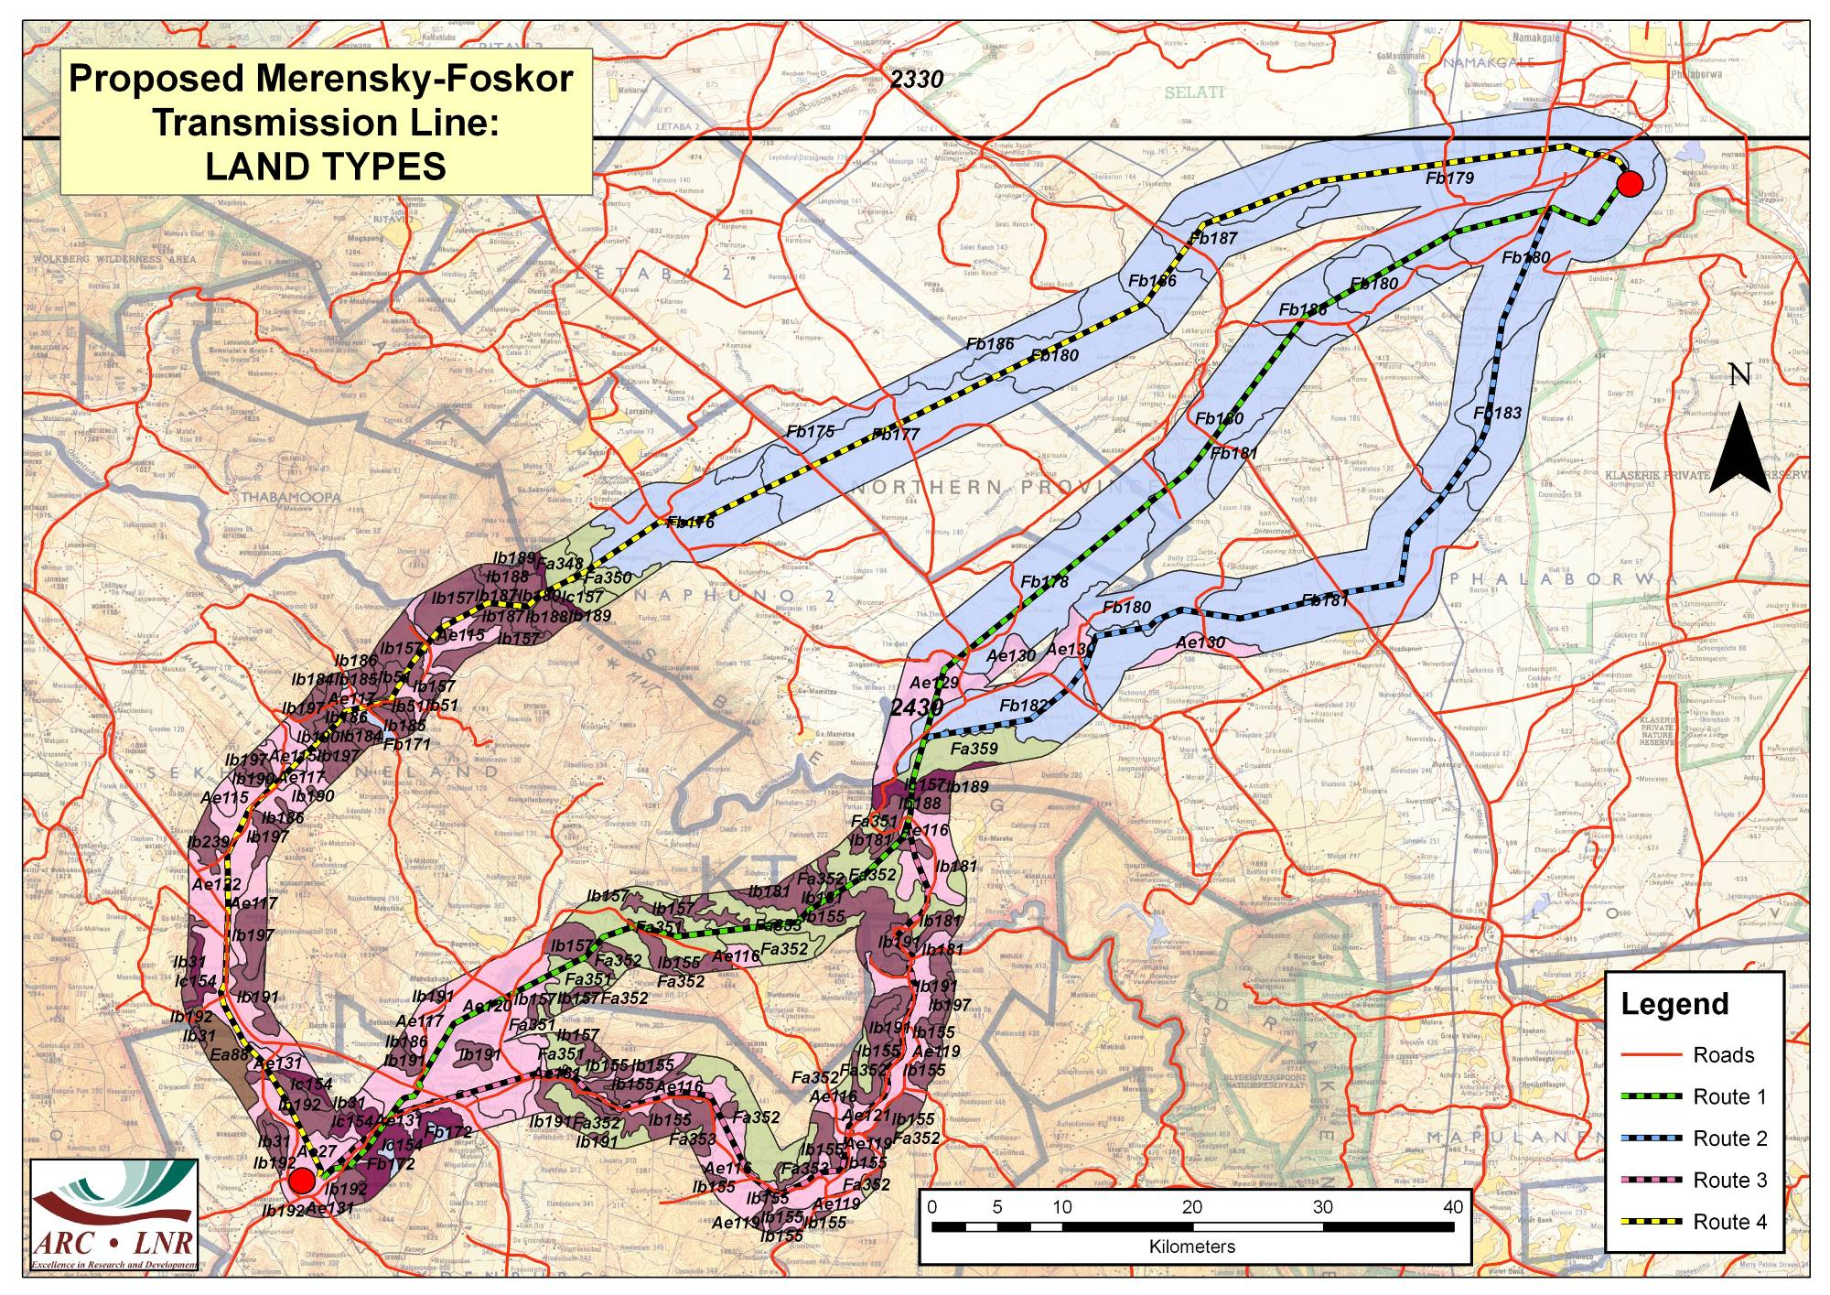

APPENDIX 2:

Agricultural Potential Map
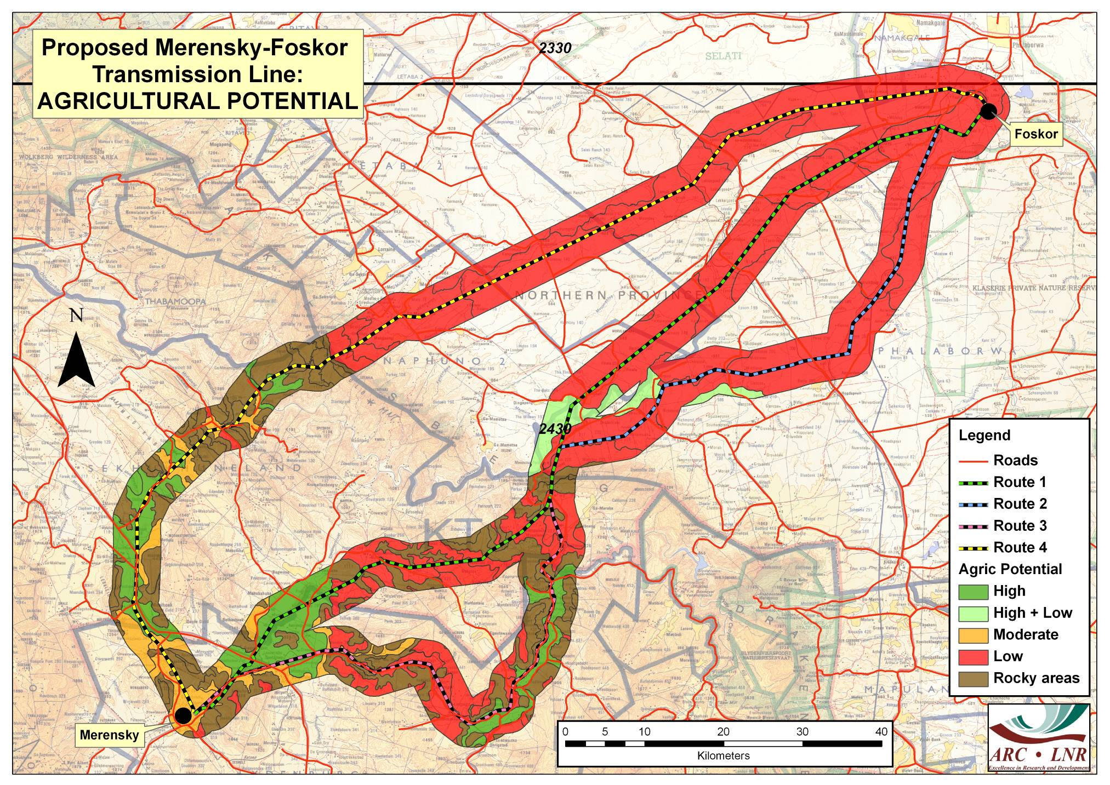
Hendrina
Prairie
Marathon

